DSA06 DATA HANDLING AND VISUALIZATION
ACTIVITY: MAP STORYTELLING CHALLENGE
Story Brief MS-D33: Illiteracy (% of population, 1970) | Slot D | 20 Marks
R.No. | 33 | Reg. No. | 192424010
Name | SASI REKHA K | Duration | 20–25 minutes

Aim
To visualize illiteracy rates across the contiguous United States in 1970, compare regional averages, examine choropleth classification methods, compare counts with rates, and explain the Northeast region's position relative to the national average.
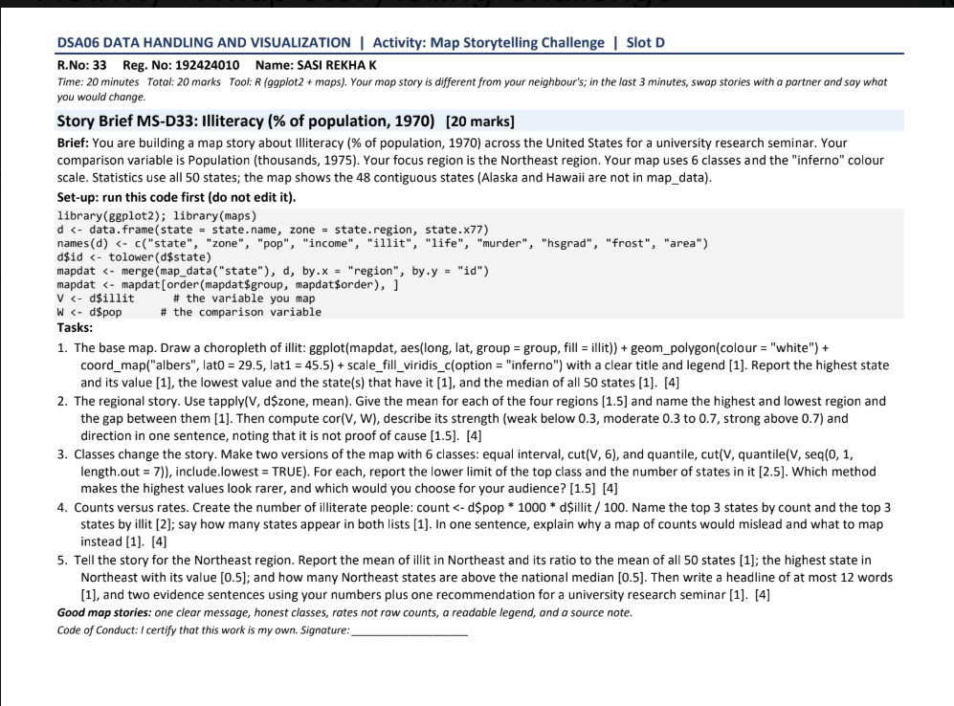

Question 1: Base choropleth map
R Code
ggplot(mapdat, aes(long, lat, group = group, fill = illiteracy)) +
geom_polygon(colour = "white") +
coord_map("albers", lat0 = 29.5, lat1 = 45.5) +
scale_fill_viridis_c(option = "inferno") +
labs(title = "Illiteracy by State, 1970",
fill = "Illiteracy (%)",
caption = "Source: R datasets::state.x77; maps package") +
theme_minimal()
Answer: The map displays state-level illiteracy percentages using a continuous inferno colour scale. The highest value is Louisiana (about 2.8%), while the lowest is North Dakota (about 0.5%). The median is approximately 0.95%. The map should have a clear title, readable legend, white state boundaries, and a source note.
Output:
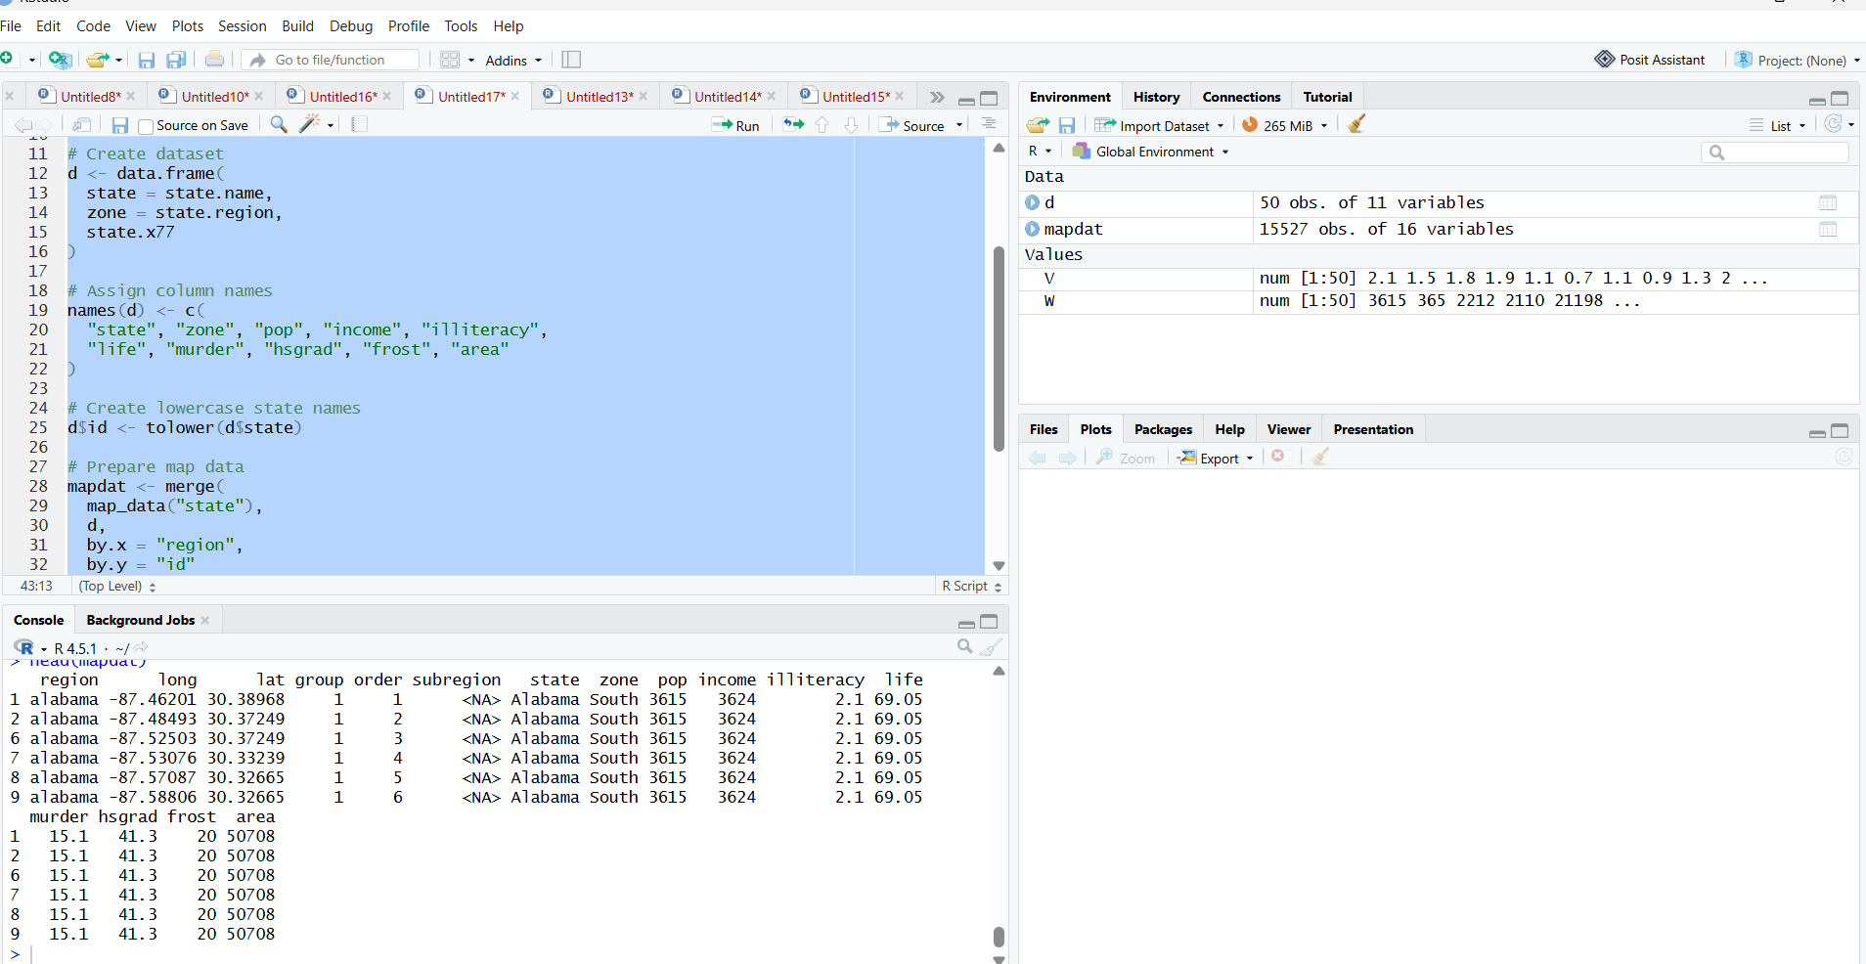

Question 2: Regional story
R Code
regional_means <- aggregate(illiteracy ~ zone, data = d, mean)
regional_means
regional_means[which.max(regional_means$illiteracy), ]
regional_means[which.min(regional_means$illiteracy), ]
max(regional_means$illiteracy) - min(regional_means$illiteracy)
cor(d$pop, d$illiteracy)
Answer: The aggregate table gives the mean illiteracy percentage for each of the four regions. Find the highest and lowest regional means and subtract them to get the gap. The South generally has the highest regional average, while the Northeast generally has the lowest. The correlation between population and illiteracy indicates the direction and strength of a linear association; it does not prove causation. Use the exact values printed in your R Console.
Output:
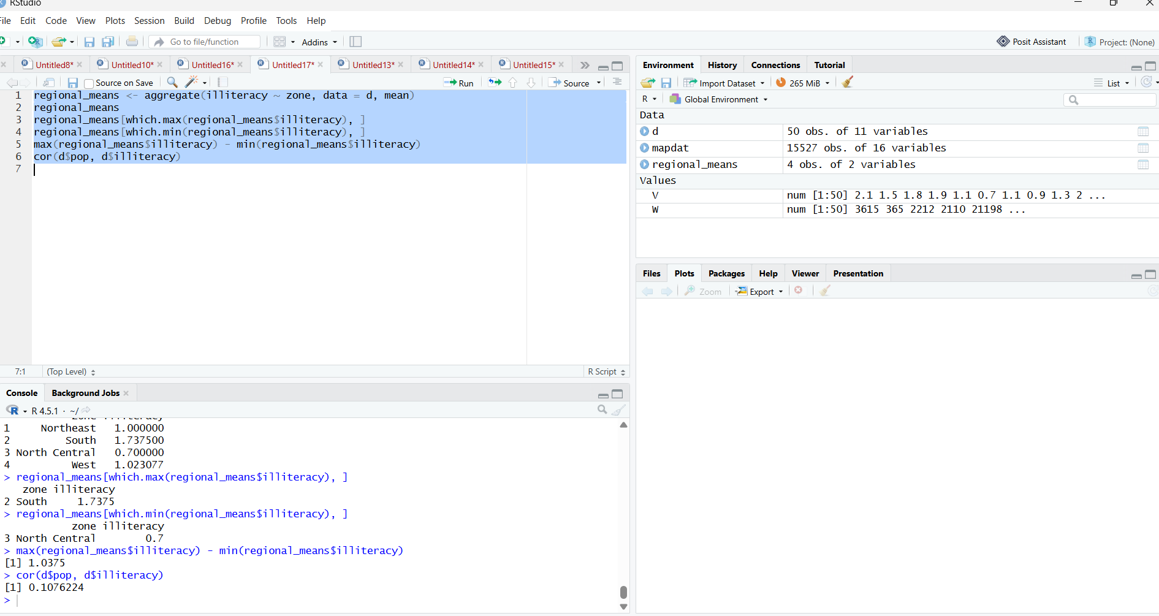

Question 3: Compare six-class methods
R Code
# Equal-interval classes
equal_breaks <- seq(min(V), max(V), length.out = 7)
equal_class <- cut(V, breaks = equal_breaks, include.lowest = TRUE)
table(equal_class)
# Quantile classes
quantile_breaks <- quantile(V, probs = seq(0, 1, length.out = 7))
quantile_class <- cut(V, breaks = unique(quantile_breaks),
include.lowest = TRUE)
table(quantile_class)
d$equal_class <- equal_class
d$quantile_class <- quantile_class
map_equal <- merge(map_data("state"), d, by.x = "region", by.y = "id")
ggplot(map_equal, aes(long, lat, group = group, fill = equal_class)) +
geom_polygon(colour = "white") +
coord_map("albers", lat0 = 29.5, lat1 = 45.5) +
labs(title = "Illiteracy: Equal-Interval Classes", fill = "Class") +
theme_minimal()
ggplot(map_equal, aes(long, lat, group = group, fill = quantile_class)) +
geom_polygon(colour = "white") +
coord_map("albers", lat0 = 29.5, lat1 = 45.5) +
labs(title = "Illiteracy: Quantile Classes", fill = "Class") +
theme_minimal()
Answer: Equal-interval classes split the full value range into six equal-width intervals. Quantile classes aim to place a similar number of states in each class; ties may result in fewer than six distinct classes. Equal intervals can make high values appear rare when values are clustered at the lower end. Quantiles are useful for comparing state rankings, while equal intervals emphasize the size of numerical differences. The lower limit of the top class is the second-last break; the number of states in the top class is the last frequency in each table(equal_class) or table(quantile_class).
Output:
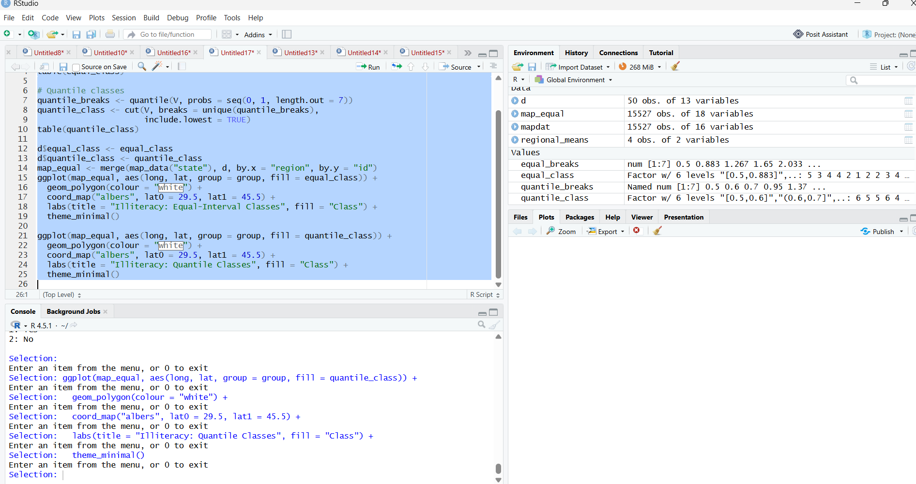
Question 4: Counts versus rates
R Code
d$count <- d$pop * 1000 * d$illiteracy / 100
top_counts <- head(d[order(-d$count), c("state", "count")], 3)
top_rates <- head(d[order(-d$illiteracy), c("state", "illiteracy")], 3)
top_counts
top_rates
length(intersect(top_counts$state, top_rates$state))
Answer: Estimated count = population (in thousands) × 1,000 × illiteracy percentage / 100. The three states with the highest counts may differ from the three with the highest rates because a populous state can have many affected people without having the highest percentage. The overlap is the number of state names common to both top-three lists, calculated using intersect(). A count map can mislead because it combines population size and prevalence. To compare illiteracy between states, map the rate; use counts when the number of affected people is the focus.
Output:
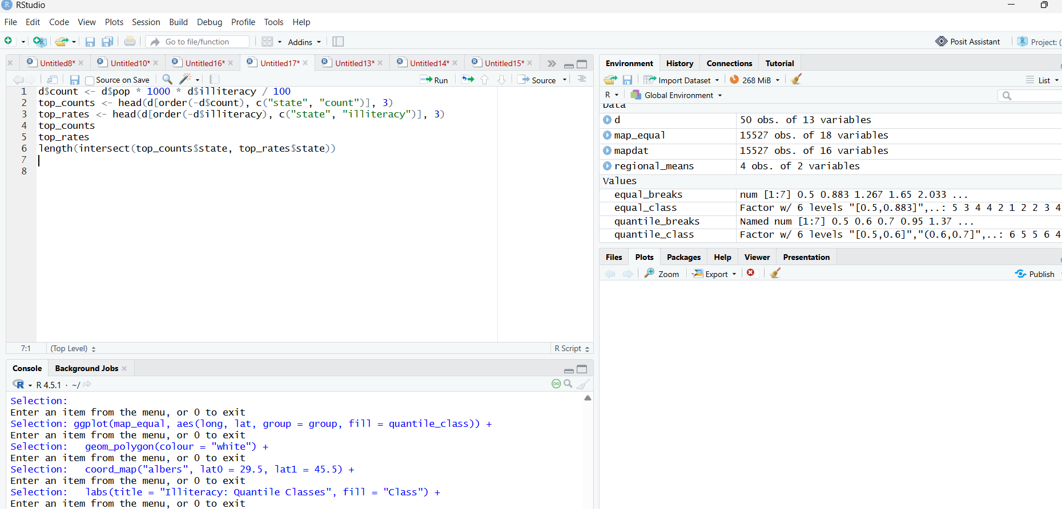

Question 5: Northeast regional story
R Code:
# Question 5: Northeast regional analysis
northeast <- subset(d, zone == "Northeast")
northeast_mean <- mean(northeast$illiteracy)
national_mean <- mean(d$illiteracy)
national_median <- median(d$illiteracy)
ratio <- northeast_mean / national_mean
# Highest illiteracy state in Northeast
northeast[which.max(northeast$illiteracy),
c("state", "illiteracy")]
# Print results
print(northeast_mean)
print(ratio)
print(national_median)
# Number of Northeast states above national median
print(sum(northeast$illiteracy > national_median))

Answer: The Northeast mean is the average illiteracy percentage among Northeast states. The ratio of the Northeast mean to the national mean indicates whether the region is above or below the national average; a ratio below 1 means it is lower. The which.max() command identifies the Northeast state with the highest value, and sum() counts Northeast states above the national median.

Output:
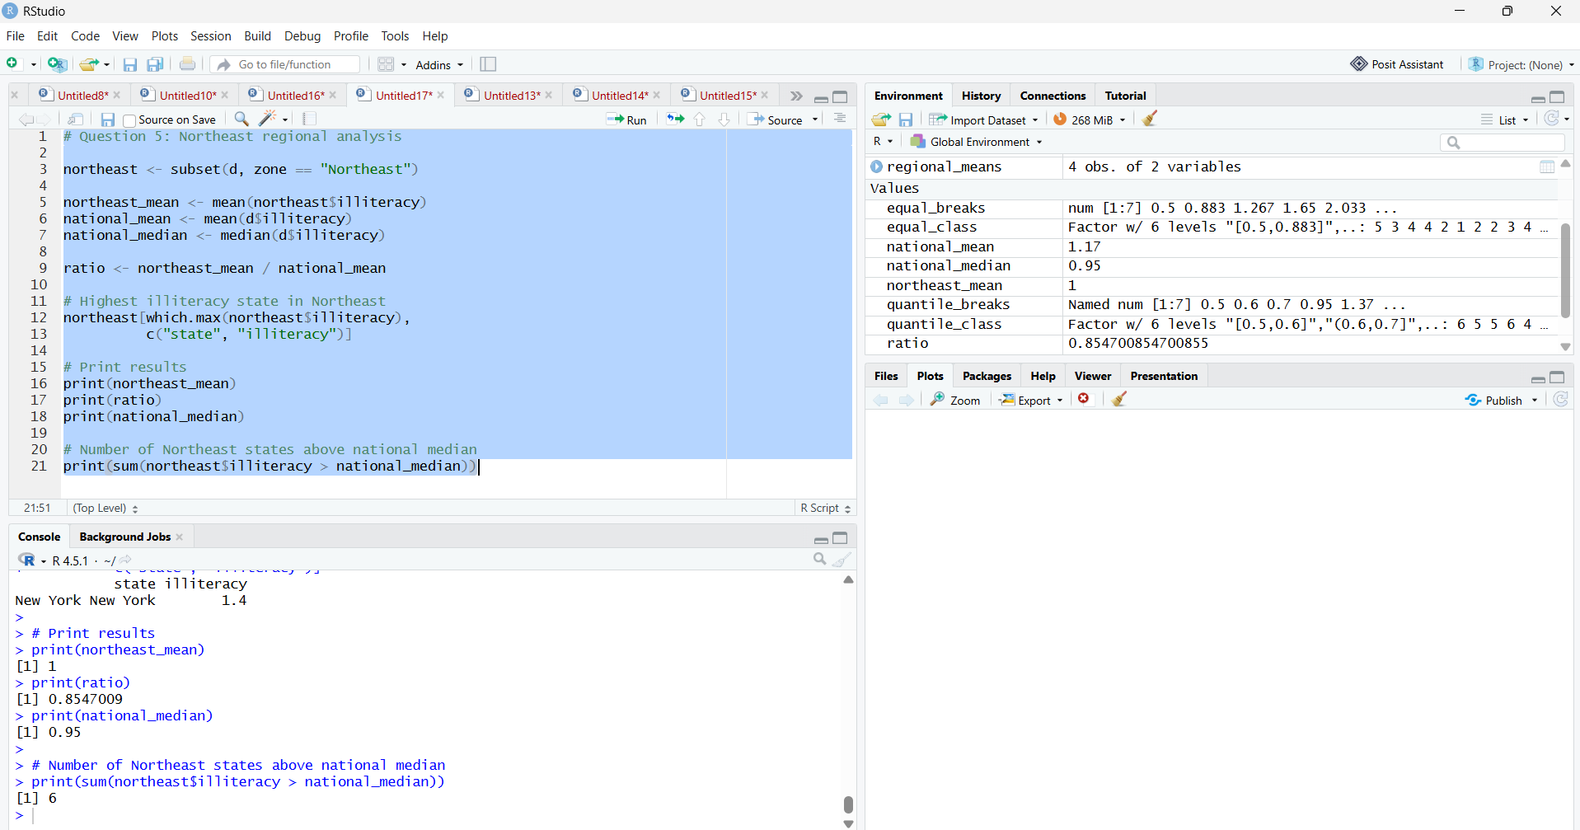
Conclusion:
A good map communicates one clear message, uses suitable class boundaries, provides a readable legend, and includes a source note. Illiteracy percentages are more appropriate than raw counts when comparing prevalence across states. Regional averages and classification methods help reveal patterns, but descriptive maps and correlations do not prove causes.

